# Design Overview for *“Live Map Of International Space Station”*

Name: Thanh Tam Vo

Student ID: 103487596

# Summary of Program

This program is an updated version of the project “International Space Station Tracking”, the program will show the current position of the International Space Station of NASA (This program can be considered as a live map of ISS). Also, it will show the trajectory of the ISS from the beginning.

The position of ISS will be presented in the following map below

*Figure 1. Earth map of the program*

# Required Roles

Describe each of the classes, interfaces, and any enumerations you will create. Use a different table to describe each role you will have, using the following table templates.

Table : Object_Management.cs

|  |  |  |
| --- | --- | --- |
| Responsibility | Type Details | Notes |
| Managing application objects by their IDs | List<string> : _listOfObject |  |

Table 2: Application_Object.cs

|  |  |  |
| --- | --- | --- |
| Responsibility | Type Details | Notes |
| Providing common features of the application objects | name : string  isHuman: bool | This is an abstract class  It also inherits from the Object_Management class |

Table 3: Craft.cs

|  |  |  |
| --- | --- | --- |
| Responsibility | Type Details | Notes |
| Demonstrating the International Space Station object in the program. | longitude : string  latitude : string | It inherits from the Application_Object class |

Table 4: Astronaut.cs

|  |  |  |
| --- | --- | --- |
| Responsibility | Type Details | Notes |
| Demonstrating the astronaut object in the program. | craft : Craft | It inherits from the Application_Object class |

Table 5: EarthMap.cs

|  |  |  |
| --- | --- | --- |
| Responsibility | Type Details | Notes |
| Demonstrating the earth map object in the program | bitmap : Bitmap  craft : Craft  _ListOfCoordinates : List<ISSCoordinate> | It inherits from the Application_Object class |

Table 6: ISSCoordinate.cs

|  |  |  |
| --- | --- | --- |
| Responsibility | Type Details | Notes |
| Demonstrating the coordinate system (involving latitude and longitude) | _latitude : double  _longitude : double | Do not inherit from any class |

# Expected UML Diagram

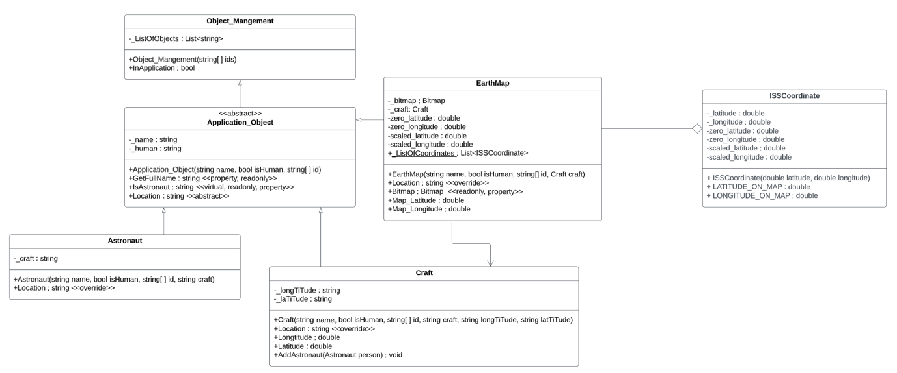

*(Screenshot from LucidChart on July 23th, 2022)*

Overview of program structure

The program show the current position of the ISS and its trajectory for analysis purposes

**\*Note:** This program uses Pure Fabrication concept by storing the JSON data in a temporary class.

The JSON format of the International Space Station does not change, according to [Open Notify (open-notify.org)](http://open-notify.org/), the JSON format of ISS is shown below

*JSON format of ISS*

*(Captured from Open Notify)*

Therefore, inside the Main program, I created two temporary class to store the data above

*The application of pure fabrication in the program*

*(Captured from my Visual Studio)*

Abstraction in program

The program will have an abstract class, which is the class called *Application_Object,* by indicating the common feature of the application object such as: name, is it a human or not, its location, etc.

*Application_Object abstract class*

*(Captured from LucidChart)*

Inheritance and Polymorphism in program

There are two classes that inherit from the *Application_Object* class, they are *Craft* and *Astronaut* because both are main objects of this console application.

Both have the *Location()* function (because they inherit from the *Application_Object* class), however, each class performs differently.

+The *Location()* function of the *Craft* class will return the craft’s latitude and longitude

+ The *Location()* function of the *Astronaut* class will return the astronaut’s current craft

The UML diagram for those classes is depicted below

*UML diagram to demonstrate the use of Inheritance and Polymorphism*

*(Captured from LucidChart)*